**Woolf, (Adeline) Virginia (1882-1941)**

SUMMARY

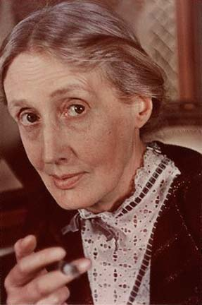

Virginia Woolf was one of the foremost literary innovators of the early twentieth century. A novelist, essayist, short-story writer and literary critic, she was also instrumental in disseminating the work of other key modernist writers, through the Hogarth Press which she ran with her husband Leonard Woolf. Author of such major works as *Mrs Dalloway¸ To the Lighthouse* and *A Room of One’s Own*, she was a key figure in the so-called Bloomsbury group of writers, artists and intellectuals active in the early twentieth century. Although her bouts of mental illness, culminating in her suicide by drowning in March 1941, for many years overshadowed appreciations of her literary output, she is now recognised as one of the most important figures in the literature and culture of the period, whether in terms of the feminist politics of her work, or her ground-breaking experiments with narrative form and technique.

**Virginia Woolf photographed by Gisèle Freund in 1939**

(url: <http://kaykeys.net/passions/virginiawoolf/index.html> - though many versions are available online)

MAIN ENTRY

# 

# Virginia Woolf was born Adeline Virginia Stephen to Sir Leslie Stephen, author and mountaineer, and Julia Prinsep Stephen. Her family had wide-ranging political and literary connections; she was encouraged to read widely, and began writing at an early age. With her sister Vanessa (Bell, the artist and interior designer) and brothers Thoby and Adrian, she produced the Hyde Park Gate News, named after the street where the family lived, from 1891 to 1895. This handwritten publication included serialisations of Woolf’s first sustained pieces of fiction, written when she was ten, entitled ‘A Cockney's Farming Experience’ and ‘The Experiences of a Pater-familias’. Although she had relatively little formal education, Woolf was tutored at home in a range of subjects, and also attended classes up to degree level at King’s College London between 1897 and 1902, in History, Greek, Latin and German.

# Woolf photographed with her father Sir Leslie Stephen in 1902.

# (url: <http://commons.wikimedia.org/wiki/File:Virginia_Woolf_with_her_father,_Sir_Leslie_Stephen.jpg>

# Following their father’s death in 1904, the Stephen siblings set up home in Bloomsbury, a then unfashionable part of London, and established a bohemian household hosting meetings of young intellectuals and artists who were to become known as the Bloomsbury Group. A member of this circle was the then civil servant Leonard Woolf, whose proposal of marriage Virginia eventually accepted (on the third time of asking) in 1911; they were married in August 1912.

**Gordon Square in Bloomsbury, London, where Woolf and her siblings lived from 1904.**

(url: <http://dovegreyreader.typepad.com/dovegreyreader_scribbles/2010/03/whistlestop-london.html>)

Woolf began publishing her writing, mainly essays in literary criticism, in her early twenties, and remained a prolific essayist and literary critic throughout her career. By the time of her marriage, she had also embarked on her first novel, a bildungsroman published as *The Voyage Out* in 1915. Her next fictional publication was ‘The Mark on the Wall’, a short story of immense narrative innovation exploring interiority as rarely before in literary fiction. It was published with Leonard’s ‘Three Jews’ as *Two Stories* in 1917 – the first publication by the Hogarth Press, which she and Leonard had set up in their home in Richmond earlier that year. Though they initially struggled with the technical difficulties involved in hand printing, the Press soon became a respected enterprise, publishing works by such key figures as Katherine Mansfield, T. S. Eliot and E. M. Forster. Hogarth were also the authorized publishers for the work of Sigmund Freud in its first English translations.

**A portrait of Woolf by her sister, Vanessa Bell (1912).**

(url: <http://www.npg.org.uk/collections/search/portrait/mw08084/Virginia-Woolf-ne-Stephen>

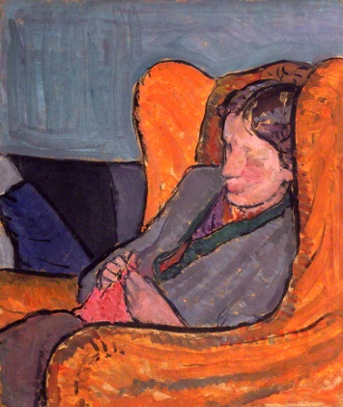Woolf’s next publication, *Night and Day* (1919), continued in the broadly realist vein of her previous novel, despite her contemporaneous innovations in the short story form. Its themes and concerns, however, in particular its depiction of the city and preoccupation with gender politics, are recognisably modernist. Her major break with traditional narrative in the novel came with *Jacob’s Room* (1922). Drawing to a large extent on the short life of her brother Thoby, who had died of typhoid fever in 1906, the novel is also an elegy for the millions of young men killed during World War One. The novel challenged conventional conceptions of character and form through the conspicuous absence of the supposedly central figure. The late teens and early 20s were also Woolf’s most productive in terms of published short fiction. The collection *Monday or Tuesday* (1921) brought together eight pieces which together display some of her most radical literary innovations in perspective, genre and language.

Woolf’s most celebrated works followed. *Mrs Dalloway* (1925) is a one-day novel using what Woolf called her ‘tunnelling’ technique to fill out the characters’ pasts through lengthy excursions into memory, while at the same time linking them through a fluid narrative often moving rapidly from one perspective to another. *To the Lighthouse* (1927) was Woolf’s most self-confessedly autobiographical novel in its depiction of the patriarch and matriarch Mr and Mrs Ramsay. Woolf stated in a diary entry that ‘writing the *Lighthouse* laid [mother and father] in my mind’. Her narrative innovation continued in this novel’s densely sensuous prose and its structure, being made up of three sections, two single days separated by the much shorter ‘Time Passes’ in which many years go by.

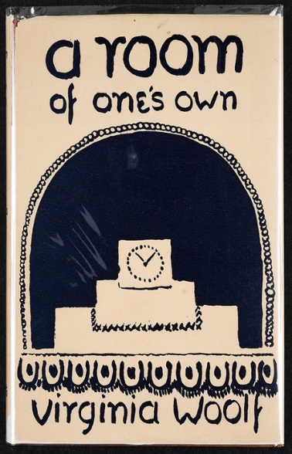

After the psychological demands of writing *To the Lighthouse*, two contrasting projects followed. Thepseudo-biography *Orlando* (1928) depicted the life and times of a sex-changing protagonist who lives for 400 years. Explicitly based on her then lover, the writer Vita Sackville-West, the novel drew on Sackville-West’s own complicated, aristocratic heritage, and included photographs of Sackville-West as Orlando. *A Room of One’s Own*, published in 1929, was based on a lecture entitled ‘Women and Fiction’ Woolf gave to a women’s college at Cambridge University in 1928, and is now a key text of feminist literary criticism and politics more generally. Though very different in style and genre from *Orlando*, both works share the desire to challenge traditional gender identities.

The cover of the first edition of *A Room of One’s Own*, designed by Woolf’s sister Vanessa Bell and published by the Woolf’s own Hogarth Press.

(url <http://www.lib.udel.edu/ud/spec/exhibits/hogarth/comercl.htm>)

Woolf’s next novel was arguably her most radical. *The Waves* (1931) alternates between the voices of six friends – or possibly aspects of the same character – describing their interrelations from childhood to maturity, with interludes describing the sun rising and then setting on a seaside landscape including an apparently abandoned house, devoid of human presence. Woolf herself envisaged it as an ‘abstract mystical eyeless book: a playpoem’. As if to emphasise her versatility, she then wrote another biography of sorts, from the perspective of the eponymous Flush, Elizabeth Barrett-Browning’s spaniel. Light-hearted in tone this text, published in 1933, playfully provokes received notions about human and animal interaction and psychology.

*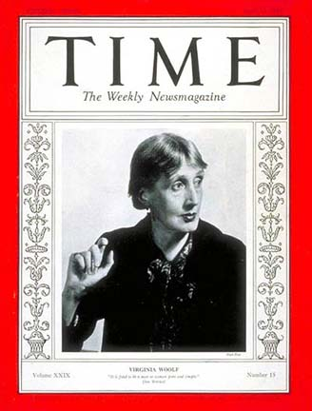The Years* (1937) is often seen as a return to a more conventional narrative mode, though it was originally envisaged as a more experimental text, alternating between a fictional family history from 1880 to ‘the present,’ and passages of political and social history. Ultimately Woolf was dissatisfied with this experiment and the two texts were developed and published separately. The non-fiction part appeared as the anti-war feminist polemic *Three Guineas* (1938). Her final novel, *Between the Acts*, was published posthumously in 1941. Woolf died with a major project on the history of English literature already part underway.

**The only surviving recording of Woolf’s voice: an essay entitled *Craftsmanship* which she wrote for broadcast on BBC radio, 29 April 1937.**

(url <http://www.youtube.com/watch?v=E8czs8v6PuI>)

Woolf photographed by Man Ray for the cover of *Time* magazine in 1937. (url: <http://kaykeys.net/passions/virginiawoolf/index.html>)

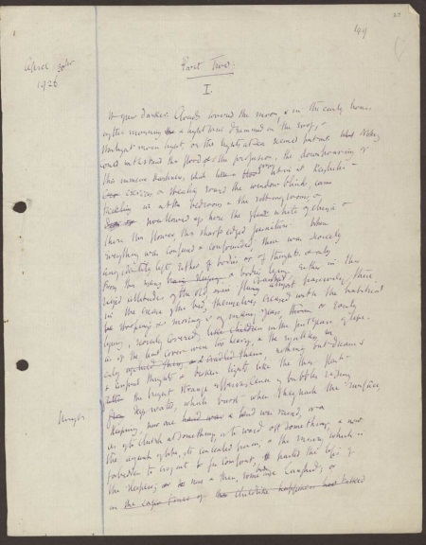

**List of Works**

Collected Works

*The Complete Shorter Fiction* (1985)

*Essays* (6 vols, 1986-2011)

*The Diary of Virginia Woolf* (5 vols, 1977-1984)

*The Letters of Virginia Woolf 1888–*

*1941* (6 vols, 1975–1980)

Novels

*The Voyage Out* (1915)

*Night and Day* (1919)

*Jacob's Room* (1922)

*Mrs Dalloway* (1925)

Original handwritten draft of Part Two of *To the Lighthouse*.

url: <http://www.woolfonline.com/?q=image/tid/8>

This item might be better as a pop-out so that it can be large enough for the handwriting to be minimally legible.

*To the Lighthouse* (1927)

*Orlando* (1928)

*The Waves* (1931)

*Flush* (1933)

*The Years* (1937)

*Between the Acts* (1941)

Short story collections

*Monday or Tuesday* (1921)

*A Haunted House and Other Short Stories* (1944)

Drama

*Freshwater: A Comedy* (1976)

Essays

*Modern Fiction* (1919)

*The Common Reader* (1925)

*A Room of One's Own* (1929)

*On Being Ill* (1930)

*The London Scene* (1931)

*The Common Reader: Second Series* (1932)

*Three Guineas* (1938)

*The Death of the Moth and Other Essays* (1942)

*The Moment and Other Essays* (1947)

*The Captain's Death Bed And Other Essays* (1950)

*Granite and Rainbow* (1958)

*Books and Portraits* (1978)

*Women And Writing* (1979)

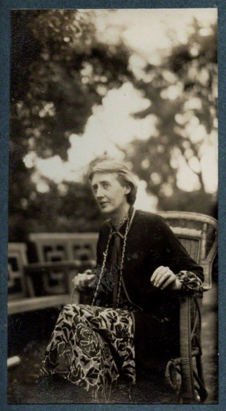Biography

*Roger Fry: A Biography* (1940)

Autobiographical writings and diaries

*A Writer’s Diary* (1953) [selected diary entries]

*Moments of Being* (1976) [autobiographical writings]

*A Moment's Liberty: the shorter diary* (1990)

*A Passionate Apprentice: The Early Journals, 1897–1909* (1990)

*Travels With Virginia Woolf* (1993) [travel writings]

*The Platform of Time: Memoirs of Family and Friends* (2008) [selected biographical writings]

### Letters

*Congenial Spirits: The Selected Letters* (1993)

Woolf photographed by her friend Lady Ottoline Morrell in 1926

url: <http://www.npg.org.uk/collections/search/portrait/mw111909/Virginia-Woolf-ne-Stephen?LinkID=mp04923&wPage=2&role=sit&rNo=43>

**Further reading**

Bell*,* Quentin (2 vols., 1972, rev. edns. 1990, 1996) *Virginia Woolf: A Biography*, London: The Hogarth Press.

Briggs, Julia (2006) *Virginia Woolf: An Inner Life,* London: Penguin.

Gordon,Lyndall (1984; rev. edn. 2006) *Virginia Woolf: A Writer's Life,* Oxford: Oxford University Press.

Lee, Hermione (1996) *Virginia Woolf*, London: Chatto & Windus.

Rose, Phyllis (1978) *Woman of Letters: a Life of Virginia Woolf*, London: Routledge and Keegan Paul.

Bryony Randall, University of Glasgow